Network Security Assignment 1

VIDIT PRASHANT GALA
252IS012

Security Analysis of a Personal Computer using the MITRE ATT&CK Framework

Task 1: System Profiling

Create a System profile table that consists of the following details: -

- OS system and version -

Microsoft Windows Version 25H2(OS Build 26200.7462)

- User privilege level (admin / standard user) -

User privilege level - Administrator
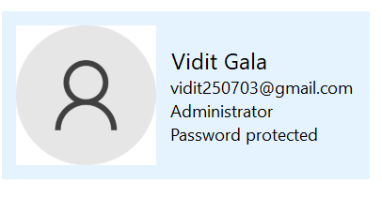

- Installed security tools (AV, firewall, EDR, etc.) -

Windows Defender Firewall - On
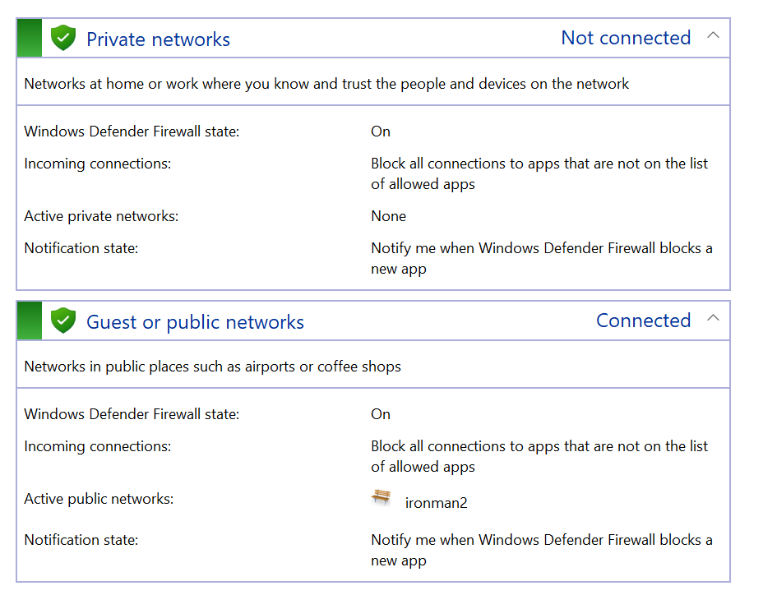
- Observe Internet Usage Pattern -

Use email frequently? — Yes, I use email very frequently, and I do get a lot of emails from random websites and sources
Download software/cracked tools? — Yes, I rarely download some cracked tools and software for some use
Use cloud storage (Drive, OneDrive)? — Yes, I heavily use cloud storage such as Google Drive for storing photos, files, and documents
Use public Wi-Fi? — Very very rarely, I do happen to use Public Wifi

Parameters | Details
OS | Windows
User Privilege | Administrator
Anti-Virus | Windows Defender
Firewall | Enabled
Internet Usage | Emails, Software, Cloud
Task 2: ATT&CK Tactic Selection

Identify at least 8 relevant ATT&CK tactics and justify for selecting them (L - Low, M - Medium and H - High)

- Reconnaissance - M
Attackers can gain information from online activity, but not much private data is present on the internet so it is a Medium Level Risk.

- Resource Development - L
This happens on the attacker side only and acquiring access and capabilities is not easy so it is a Low Level Risk.

- Initial Access - H
Phishing, fake downloads, unsafe links, etc these all are very easy for an attacker to gain access info from system so it is a very High Level Risk.

- Execution - H
If malicious files run which are downloaded from somewhere then a lot of damage can happen quickly and Windows Defender may help but it depends a lot on user behavior. So, it is a High Level Risk.

- Persistence - M
Malware can use startup items or scheduled tasks, but Defender can often detect these over time. So, it is a Medium Level Risk.

- Privilege escalation - M
Gaining admin rights is possible using exploits, but Windows protections and updates reduce success rate. So, it is a Medium Level Risk.

- Defense evasion - H
Advanced malware can bypass basic Defender or hide as normal files, so it is a High Level Risk.

- Credential Access - H
Saved browser passwords and typed credentials are valuable targets which an attacker may be able to find from internet where i may have logged in on compromised websites. So, it is a High Level Risk.

- Discovery - H
Once inside, an attacker can easily list users, files, and software using normal system commands making it a High Level Risk.

- Lateral Movement - L
Since the system is standalone, attacker has limited chance to move to other machines so it is a Low Level Risk.

- Collection - H
Files, emails, and cloud data can be easily gathered if system is compromised, and I do happen to have a lot of private data on cloud thus making it a High Level Risk.

- Command & Control - M
Malware can connect out using normal internet traffic, but firewall and Defender may sometimes block it so it is a Medium Level Risk.

- Exfiltration - H
Stolen data can be sent out over internet quietly, and basic tools may not always notice so it is a High Level Risk.

- Impact - H
Attacker can cause data loss, corruption, system crash, or misuse of your accounts so it is a High Level Risk.

Based on the ratings of low, medium and high I have shortlisted only the High Risk Level Tactics for further analysing and these tactics are:
Initial Access, Execution, Defense evasion, Credential Access, Discovery, Collection, Exfiltration and Impact.

Task 3: Technique-Level Analysis

Figure 1: Scanning threats using windows defender
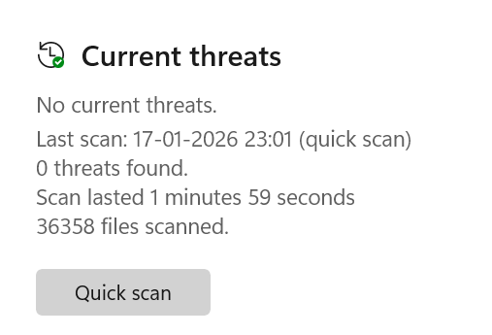
Figure 2: Firewall not blocking multiple apps, making the system a bit vulnerable
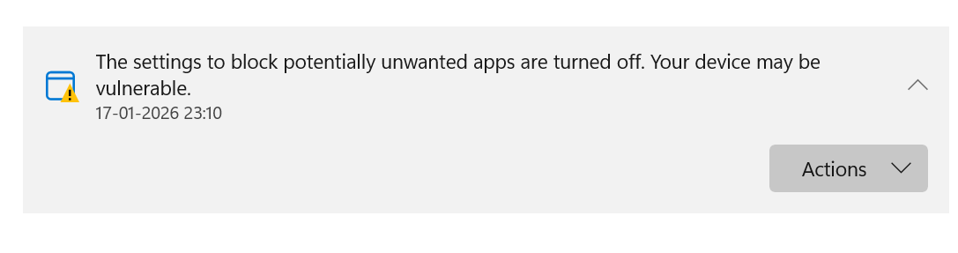
Figure 3: Login Logs Details
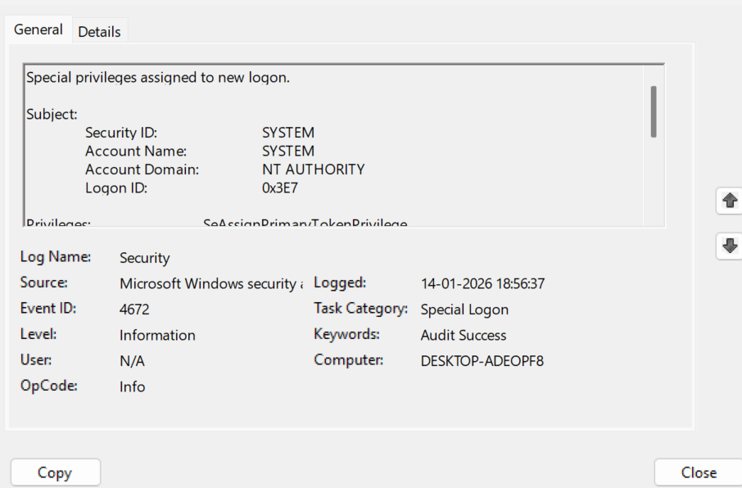

Figure 4: User account management logs
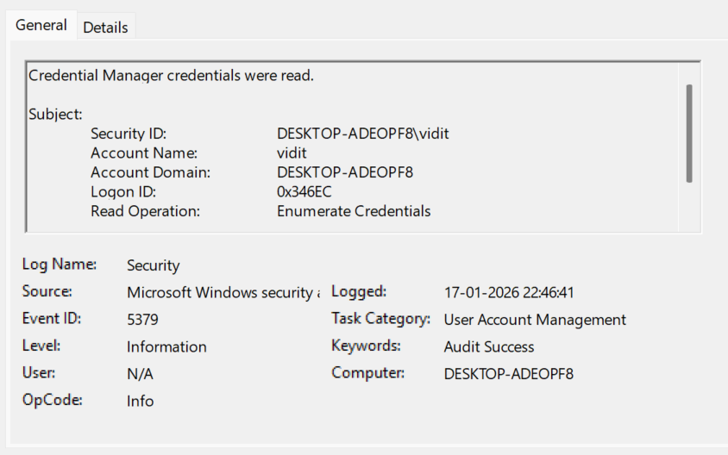

Figure 5: Task Manager checking if unwanted/malicious events running or not
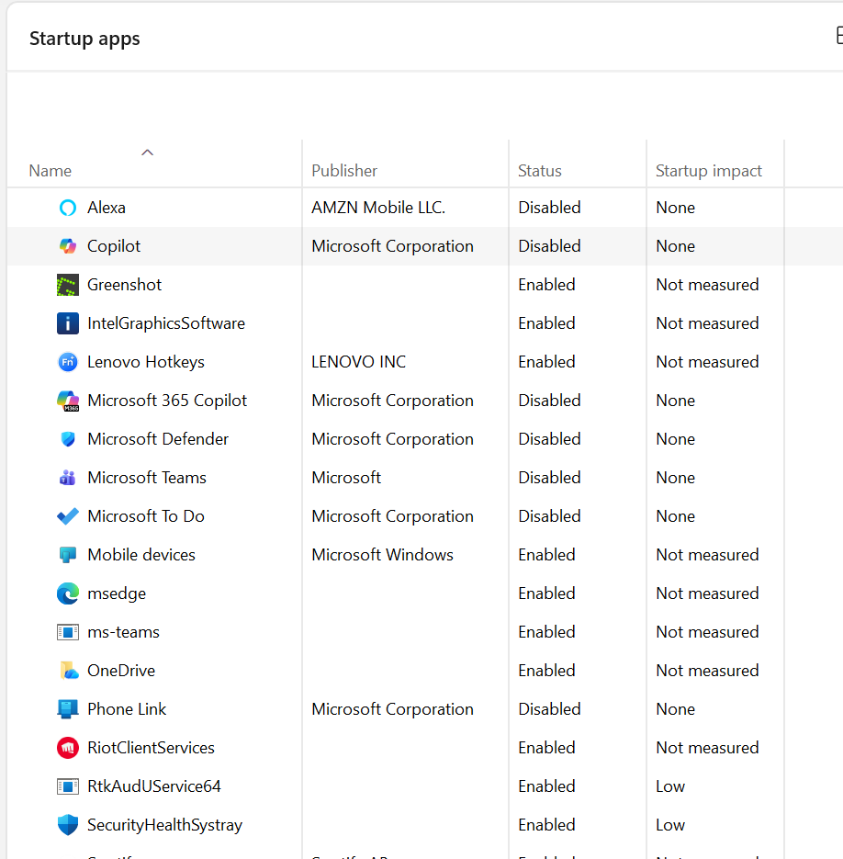
Figure 6: Task Scheduler checking startup apps when the system starts if any malware runs at that time or not
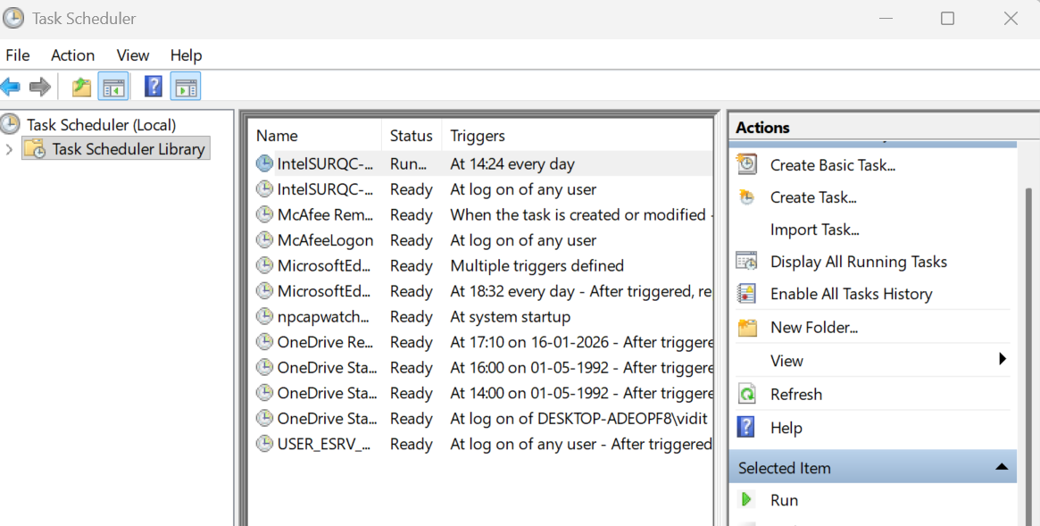

Figure 7: User Account Control panel settings if malware tries to make changes to the system
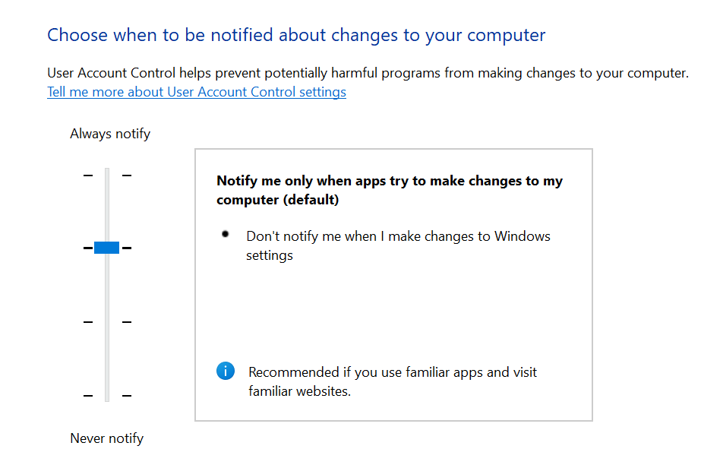

Figure 8: Critical/Error logs in case of attack or anything
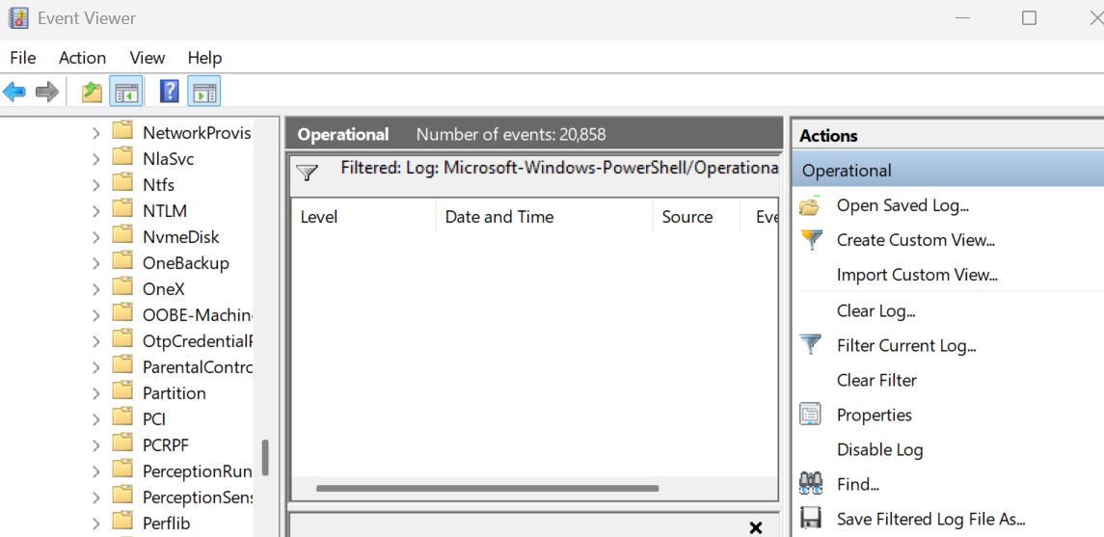

A. Initial Access -
Phishing :-
Attacker can send fake emails or messages to trick into entering passwords and not knowing if a person is genuine or not. (Risk - High)
Slightly partially detectable by Windows Defender and email spam filters. (Current Visibility - Low)

Content Injection :-
As I do keep visiting websites, I may visit a compromised website, so the attacker can inject malicious scripts that may download malware. (Risk - High)
Detectable by Windows Defender browser protection, also the firewall has limited role since the traffic looks normal. (Current Visibility - Medium)

Valid Accounts :-
I do keep logging and creating accounts in multiple websites, and I do happen to use a same set of passwords everywhere so an attacker can use stolen or guessed passwords to log in as a normal user and access my files or system resources. (Risk - High)
Hard to detect if behavior looks normal, can be prevented at a very less chance by Defender account protection. (Current Visibility - Low)

B.Execution -
Input Injection :-
I do happen to download a lot of apps and softwares from web so an attacker can enter malicious input in apps or websites that I use, causing harmful commands or scripts to run on my system. (Risk - Medium)
Sometimes it is detected by Windows Defender and browser protection. (Current Visibility - Medium)

User Execution :-
Attacker can trick into opening a malicious file or link, which then runs malware on my system. (Risk - High)
Detectable by Windows Defender real-time scanning. (Current Visibility - High)

Scheduled Task/Job :-
Malware creates a scheduled task to run itself every time the system starts or at fixed times. (Risk - Medium)
Detectable by Windows Defender scans and checking Task Scheduler but that happens very rarely so the attack is a bit risky for the system. (Current Visibility - Medium)

C.Defence Evasion -
Rootkit :-
Malware hides itself deeply in the system to control files, processes, or startup without being noticed. All the important and secure files may be lost. (Risk - High)
Very hard to detect, but Windows Defender can catch known rootkits and firewall gives little help against internal rootkits. (Current Visibility - Low)

Email Spoofing :-
Attacker can send emails that look like they came from trusted people to trick into clicking links or sharing data. This type of attack is very easy to infiltrate. (Risk - High)
Partially detectable by email provider filters and Defender. (Current Visibility - Medium)

Valid Accounts :-
I do keep logging and creating accounts in multiple websites, and I do happen to use a same set of passwords everywhere so an attacker can use stolen or guessed passwords to log in as a normal user and access my files or system resources. (Risk - High)
Hard to detect as the behavior looks normal, but it can be prevented at a very less chance by Defender account protection. (Current Visibility - Low)

D.Credential Access -
Network Sniffing :-
On unsecured Wi-Fi or public Wifi which rarely I do happen to use, attacker can capture the network traffic to read data like logins or messages. (Risk - Medium)
Hard to detect even using firewall or Windows Defender. (Current Visibility - Low)

Adversary in Middle :-
Attacker positions between the system and a website to alter or steal the data the I may send or receive. (Risk - High)
Sometimes detected by certificate warnings, warnings may be shown sometimes but the user often does not see it. (Current Visibility - Medium)

Credentials from Password Stores :-
Malware steals saved passwords from browsers or apps on the system. (Risk - High)
Sometimes it is detectable by Windows Defender malware scans. (Current Visibility - Low)

E.Discovery -
Account Discovery :-
Attacker can scan the system to find user accounts, admin accounts, or logged-in sessions to plan further attacks. (Risk - High)
Sometimes detected by Defender behavior monitoring. (Current Visibility - Low)

Network Sniffing :-
On unsecured Wi-Fi or public Wifi which rarely I do happen to use, attacker can capture the network traffic to read data like logins or messages. (Risk - Medium)
Hard to detect even using firewall or Windows Defender. (Current Visibility - Low)

Software Discovery :-
Attacker can check what software is installed to find vulnerable or outdated programs to exploit. (Risk - Medium)
Partially detectable by Defender behavior alerts. (Current Visibility - Low)

F.Collection -
Email Collection :-
Malware or an attacker can access my email app or browser session to copy all the important emails and contacts. (Risk - High)
No clear sign when emails are copied in background. (Current Visibility - Low)

Data from Cloud Storage:-
If the cloud account is compromised, attacker can download files from Google Drive, OneDrive, etc. using the system session. (Risk - High)
Hard to notice locally. (Current Visibility - Low)

Data from Network Shared Drive :-
Attacker can access shared folders on the network and copy files using your account permissions. (Risk - Medium)
Sometimes seen in access logs but rarely a user checks it. (Current Visibility - Medium)

G.Exfiltration -
Transfer Data to Cloud Account :-
Malware uploads files from the system to the attacker’s cloud storage using my internet connection. (Risk - High)
Hard to notice unless data usage spikes. (Current Visibility - Low)

Automated Exfiltration :-
Malware automatically sends my data to attacker servers at regular intervals without the system noticing. (Risk - High)
Detectable by unusual network activity as it runs silently in background. (Current Visibility - Low)

Data Transfer Size Limits :-
Attacker can send data in small chunks to avoid detection by security tools. (Risk - High)
Very hard to detect as the transfers are very small to be even noticed. (Current Visibility - Low)

H.Impact -
Email Bombing :-
Attacker can flood my mail inbox so mail apps and browser email becomes slow and important security emails get buried, making my system vulnerable. (Risk - Medium)
The attack can be partially detected by Windows Defender and email provider spam filters and the firewall also has little effect on email floods. (Current Visibility - Medium)

Data Manipulation :-
If malware enters my system then it can change or delete files, documents, or saved data on system. (Risk - High)
The attack is detectable and mostly preventable by Windows Defender, while firewall only blocks some external access. (Current Visibility - Medium)

Network Denial of Service :-
Attacker can flood internet connection so that my system becomes slow and thus cannot access websites. (Risk - Medium)
The attack is detectable as sudden high network usage spikes which allows firewall to give limited protection— which is handled by the ISP. (Current Visibility - Medium)

Tactic | T-ID | Technique Name | Current Visibility | Risk Level
Initial Access | T1566 | Phishing | Low | High
Initial Access | T1659 | Content Injection | Medium | High
Initial Access | T1078 | Valid Accounts | Low | High
Execution | T1674 | Input Injection | Medium | Medium
Execution | T1204 | User Execution | High | High
Execution | T1053 | Scheduled Job | Medium | Medium
Defence Evasion | T1014 | Rootkits | Low | High
Defence Evasion | T1672 | Email Spoofing | Medium | High
Defence Evasion | T1078 | Valid Accounts | Low | High
Credential Access | T1040 | Network Sniffing | Low | Medium
Credential Access | T1557 | Adversary In the Middle | Medium | High
Credential Access | T1555 | Passwords Stores | Low | High
Discovery | T1087 | Account Discovery | Low | High
Discovery | T1040 | Network Sniffing | Low | Medium
Discovery | T1518 | Software Discovery | Low | Medium
Collection | T1114 | Email Collection | Low | High
Collection | T1530 | Data of Cloud Storage | Low | High
Collection | T1039 | Data from Shared Drive | Medium | Medium
Exfiltration | T1537 | Transfer Data to Cloud | Low | High
Exfiltration | T1020 | Automatic Exfiltration | Low | High
Exfiltration | T1030 | Data Transfer Size Limit | Low | High
Impact | T1667 | Email Bombing | Medium | Medium
Impact | T1565 | Data Manipulation | Medium | High
Impact | T1498 | Network DOS | Medium | Medium
Task 4: ATT&CK Coverage Matrix

Detection (D): Low / Medium / High
Prevention (P): Low / Medium / High
Overall Risk (R): Low / Medium / High

Tactic | Detection | Prevention | Overall Risk
Initial Access | Low | Low | High
Execution | Medium | Medium | Medium
Defence Evasion | Low | Low | High
Credential Access | Low | Medium | High
Discovery | Low | Low | Medium
Collection | Low | Medium | High
Exfiltration | Low | Low | High
Impact | Medium | Medium | High

Green = Low(1), Yellow = Medium(2), Red = High(3)
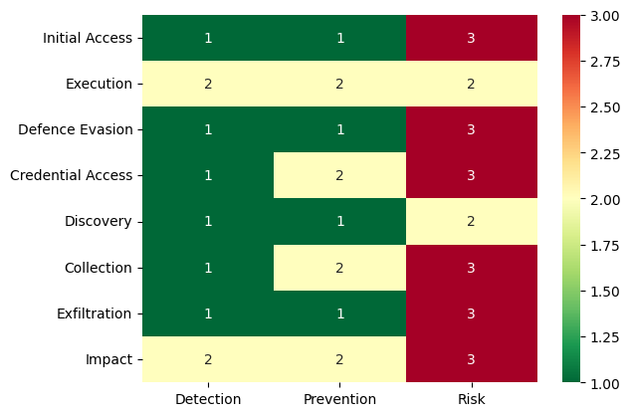

Task 5: Security Gap Identification

Top 5 Security Gaps

1. Weak Credential Protection (Valid Accounts, Password Stores)
I happen to reuse the same passwords across many websites, making credential theft extremely dangerous. If one site is breached, attackers can reuse those credentials to access my system, email, cloud storage and other services. High risk + very low detection.

2. Poor Visibility into Data Exfiltration
Techniques like automated exfiltration, transfer to cloud, and small-size data transfers are almost invisible. Data can leave the system quietly without any strong alert from Defender or firewall. High risk + poor detection

3. High Exposure to Phishing and Email Spoofing
I have difficulty in judging whether emails are genuine. Phishing and spoofed emails are a major entry point and lead directly to Credential theft, Malware execution and Account compromise. High risk + low detection.

4. Weak Defense Against Stealth Malware (Rootkits)
Rootkits are extremely dangerous because they hide deeply in the system.
Basic tools like Defender may miss advanced rootkits. High Risk + low/medium detection.

5. Limited Monitoring of Internal Activity (Discovery & Collection)
Account discovery, software discovery, email collection, and cloud data access are rarely visible to the user. Attackers can fully map your system and collect sensitive data before I notice anything wrong. High Risk + low detection.

Most Likely Attack Path
Phishing → Credential Theft → Valid Account Use → Data Collection → Silent Exfiltration

Step 1: Initial Access – Phishing or Email Spoofing
I receive a fake email that looks genuine. I click a link or download a file, or enter credentials on a fake page.

Step 2: Credential Access – Password Theft
My reused password gets stolen. Attacker logs in using valid credentials, which looks like normal behavior.

Step 3: Execution – User Execution
If I mistakenly open a malicious file or link then due to that malware may get installed in the system.

Step 4: Defense Evasion – Rootkit or Stealth Techniques
Malware hides from Defender and normal system view. Malware stays in the system and works everytime system is started.

Step 5: Collection
Emails, cloud files, and local documents are copied.

Step 6: Exfiltration
Data is sent slowly and quietly using Automated exfiltration, Cloud uploads and Small-size transfers

Highest-Risk ATT&CK Tactic

Credential Access
Credential Access is the most dangerous tactic for the system because:
- I reuse passwords across many sites
- Once a password is stolen, a lot of critical and private information can be leaked.
- Detection is very low
- One stolen password can lead to:
  - Email takeover
  - Cloud data theft
  - System compromise
  - Social engineering of others

Task 6: Mitigation & Hardening Plan (15%)

Application Whitelisting

Configure Windows Defender to allow only approved apps, and block all unknown executables, scripts, and installers by default. It works by stopping malware from running or auto-starting.

Privilege Reduction
Use a standard user account and enable high-level user account control and run admin rights only when absolutely required. This lowers the risk of rootkits, scheduled-task abuse, password theft, and system manipulation.

Strong Credential Protection
Use unique passwords for every site, store them in a password manager, and enable 2-factor authentication wherever possible.

Logging and Monitoring Improvements
Enable Windows logs, Defender history, and firewall logs, and regularly review logins, startup items, and scheduled tasks. It works by spotting unusual activity, connections, and data movement early.

Network Hardening
Avoid public Wi-Fi, use HTTPS, enable the firewall and apply DNS filtering to block unsafe sites. It works by protecting data in transit and blocking suspicious network traffic.

Backup and Recovery Controls
Maintain regular backups, keep one offline copy and test restores to ensure data can be recovered. It works by enabling recovery from ransomware, deletion, corruption, and system failure.

User Awareness and Behavior Control
Verify emails and links, avoid unknown downloads, check URLs, and never reuse passwords. It works by reducing phishing success and malicious user actions.

Mapping Table

Control | Mitigated ATT&CK Tactics
Application Whitelisting | Initial Access, Execution, Persistence, Defense Evasion
Privilege Reduction | Privilege Escalation, Persistence, Defense Evasion
Credential Hardening | Credential Access, Valid Accounts, Collection
Logging & Monitoring | Discovery, Command & Control, Exfiltration
Network Hardening | Sniffing, MITM, C2, Exfiltration
Backup & Recovery | Impact, Data Manipulation
User Awareness | Initial Access, Execution, Credential Access

